**MS Underwater Effect**

**Created by:** Marcos Ismael Schultz

**Site:** [www.schultzgames.com](http://www.schultzgames.com)

**Email:** [marcos11-24@hotmail.com](mailto:marcos11-24@hotmail.com)

'MS Underwater Effect' is an extremely easy and intuitive system to use. It was made to create underwater effects easily on any camera. The system has several effects, such as:

* Distortion of the image
* Image coloring under water
* Droplet effects on the screen
* Image haze under water
* Limitation of vision under water
* Underwater sounds.

**How to use:**

**1** - Add the component "**MSUnderWaterEffect**" in your player's camera.

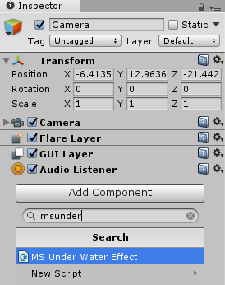

Some extra components will also be added automatically to the camera. They are necessary for the operation of the system depending on the type of detection selected. They can be removed if water is detected using Ray Cast or a fixed height value.



**2** - Now you must adjust the object representing the water in your game. To do this, simply add a collider to your object, delimiting exactly the top surface of the object, as shown below.

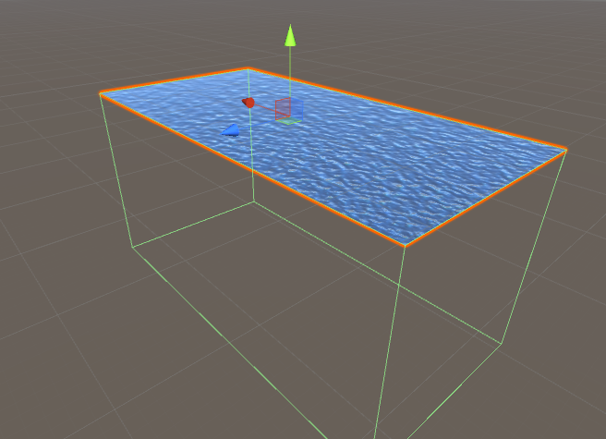

When the camera of your player is within that collider, the effect will be activated. Then you must adjust the collider accordingly.

**3** - After adjusting the collider, you should check the "IsTrigger" option on it, so the camera can use it as a trigger.

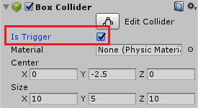

**4** - You should now add a tag for this object that represents the water so that the code can recognize it.

Click "Add Tag"

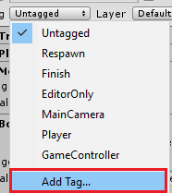

Create a new tag with the name you want.

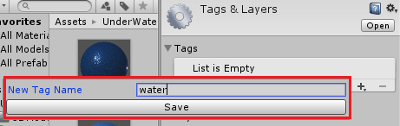

Associate this tag with the object that represents the water in your game, the same object on which you previously added the collider.

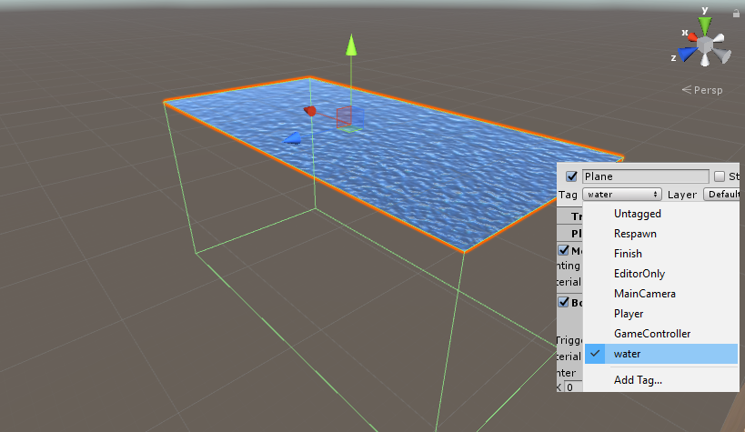

**5** - You must now configure the "MSUnderWaterEffect" component. To do this, just position the mouse cursor over the name of the variables, to view a tip that will appear on the screen indicating what each variable does. In this way, it is possible to configure the system to act according to your project.

To configure the properties of the component, you must enter the characteristics you want for each water. To do this, start the array "waters".

You must enter the number of "water objects" you have in your scene and click "**enter**" on your keyboard.

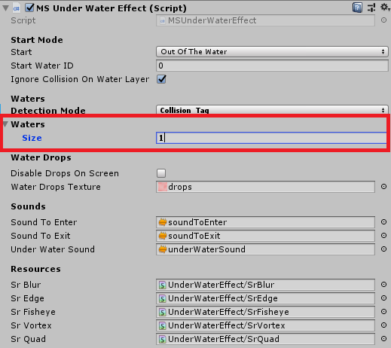

A new instance of the class will be created. Now you can configure the various types of water you have in your scene.

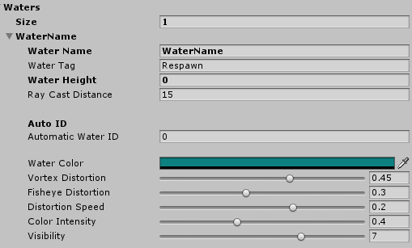

It is suggested to use water detection by collision, looking for the tag of the collided object, however, other methods are supported by the code, such as the height of the water, or even the detection of an irregular surface of water by through a RayCast.

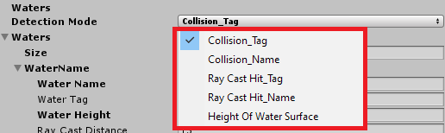

The code still has some sound effects, they are:

* Sound when the player goes underwater.
* Sound when the player is underwater.
* Sound when the player comes out from under the water.

The code also has a public variable, called **underWater**, which lets you know if the effect is active or not.

A public function is also exposed, allowing the effect to be enabled or disabled through other codes, by calling the public function:

**EnableWater (bool enable, int indexWater);**

If you have questions about how to use the system, just contact us by email: **marcos11-24@hotmail.com**